**Chameleon Compact OPO/MPX Installation Training, GDP Q414**

1.0 Purpose 1

2.0 Scope 1

3.0 Introduction to the Chameleon Compact OPO 2

3.1 Concept 2

3.2 Configurations and Specs 3

3.3 Tuning and Control 3

4.0 Pre-Installation 4

5.0 Packaging 4

6.0 Initial Setup 5

7.0 Startup 6

8.0 Alignment 7

8.1 Head Alignment 7

8.2 Spectrometer and Fast PD Alignment 8

8.3 Pump-In Alignment 10

8.4 Cavity Alignment 11

8.5 Start OPO 13

8.6 Optimisation 14

9.0 Complete Installation 16

9.1 Data Collection 16

9.2 Save OPO folder 16

9.3 Customer Training 16

10.0 Troubleshooting 18

10.1 PD board position adjustment (ref: section 8.2) 18

10.2 Adjustment of OC mounting position (ref: section 8.4) 18

10.3 ‘No Pump’ message 19

10.4 Poor signal power 19

10.5 Compact OPO software does not connect to the head 19

10.6 Configuration settings corrupted during installation. 19

10.7 In case of laser replacement 19

10.8 De-install of Compact OPO 19

11.0 Chameleon MPX 20

11.1 Introduction to the Chameleon MPX. 20

11.2 MPX cavity overview 21

11.3 MPX cavity alignment 21

12.0 Remote Diagnostics 24

12.1 Teamviewer method. 24

12.2 Bomgar method 25

13.0 Spares List 26

14.0 Further Support 26

# Purpose

To document service procedures required to successfully install the Chameleon Compact OPO, and the Chameleon MPX.

# Scope

The training course covers installation of the standard Chameleon Compact OPO only, 1181974, (does not include Compact OPO VIS and other variants) and the Chameleon MPX, 1270765. Trainees are assumed to have completed the Chameleon training class.

# Introduction to the Chameleon Compact OPO

NB: To avoid confusion, the main body of this training document refers by default to the standard Chameleon Compact OPO. For information relating specifically to the Chameleon MPX variant, please refer to section 11.

## Concept

* Compact
* Hands-free (‘black box’)
* Wavelength extension into the near IR

The Chameleon Compact Optical Parametric Oscillator was designed specifically to use the Chameleon as a pump source. It extends the wavelength coverage of the Chameleon itself into the near IR, which is useful for microscopy applications, typically 2-photon excitation of fluorescent proteins. It achieves this by frequency conversion of the original into two longer wavelengths.

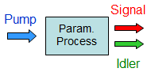

By convention, pump < signal < idler (e.g. 800nm pump < 1100nm signal < 2933nm idler.

The phase-matching conditions for efficient conversion are met by using a periodically-poled crystal. One of the key elements of the Compact OPO, i.e. that the pump and signal wavelengths can be independently tuned, is achieved by using a fan-poled crystal - by moving the crystal in the vertical direction, different poling periods are available, allowing the optimum phase-matching for a given combination of pump and signal.

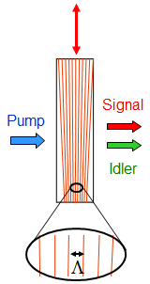

Key points:

* OPO cavity resonant for the signal, not idler
* Synchronously pumped, repetition rate OPO = repetition rate Chameleon
* No timing jitter (note: approx. 5.5ns delay between Chameleon straight-through beam and OPO signal)
* Independent pump/signal tuning

## Configurations and Specs

The Compact OPO can be pumped by Chameleon Ultra and Vision lasers, but not currently by the Vision-S.

For older Chameleons in the field, the factory should be consulted.

For up-to-date information please refer to the published datasheet at coherent.com

Standard configuration has an approximately 85/15 split, i.e. when in OPO mode, ~85% of the Chameleon power goes to pump the OPO cavity with ~15% passing through (undepleted). MaxIR and idler options must be specified at time of order.

## Tuning and Control

The Compact OPO has three sensor elements;

* an on-board spectrometer to monitor the pump and signal wavelengths (1)
* a fast photodiode to monitor the pump repetition rate (2)
* a slow photodiode to monitor the signal power (3)

It uses this information to tune the active elements in the OPO cavity;

* crystal position (phase-matching) (4)
* output coupler position (wavelength tuning) (5)
* piezo-mounted mirrors (maximise power) (6)

Refer to Figure 3.3.1 below for the location of these elements.

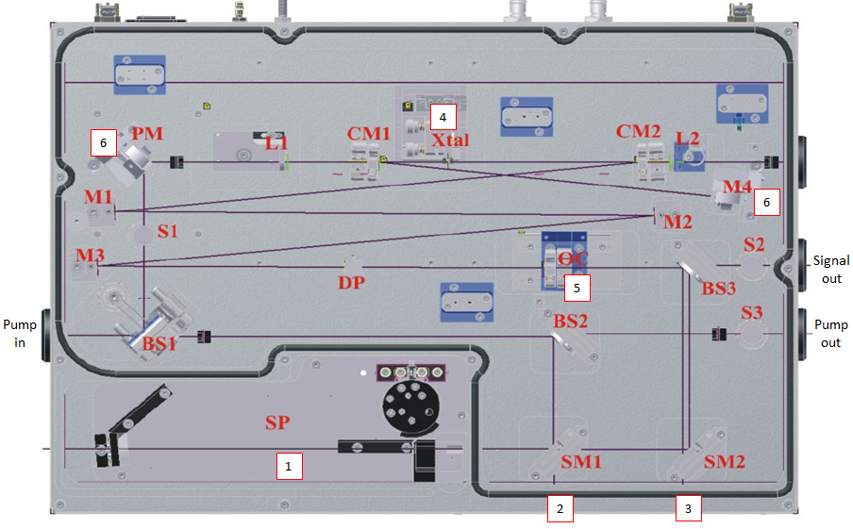

**Figure 3.3.1**

# Pre-Installation

Chameleon laser must be installed as per standard service procedures. In particular, the CW and q-switch pump power levels must have been calibrated using a Rees LSA-201 Spectrum Analyser, and the laser must be thermally stabilised.

The user should provide;

* 4 x single phase outlets (100-240Vac, 50-60Hz).
* ~CoolFlow IGE
* Suitable optical table

NB: the pump laser and compact OPO should be configured in-line and with no intermediate steering optics. If this is not possible/desirable, then Factory Support should be contacted in advance of the installation (see section 13.0).

The recommended distance between laser and OPO is 60-150mm. Note that the pump focusing will be impacted if this spacing is exceeded.

Special alignment targets and tools are included in the accessory kit of the Compact OPO. In addition, it is useful for the service engineer to carry with them a USB mouse.

# Packaging

The shipment will consist of three boxes as follows;

|  |  |  |
| --- | --- | --- |
| Box 1 | OPO Head, controller, accessory kit | 1200 x 800 x 620 mm |
| Box 2 | Chiller | 540 x 360 x 530 mm |
| Box 3 | MRU | 580 x 550 x 210 mm |

On receipt of the Compact OPO, the customer should inspect the packing crates (3) for signs of rough handling or damage. They should take pictures and report any damage to Coherent Field Service.

The customer should NOT remove the OPO from its’ packing crate.

Following installation, it is strongly recommended that the packaging is retained by the customer for future use. Failure to do this may cause delay and expense in the future.

# Initial Setup

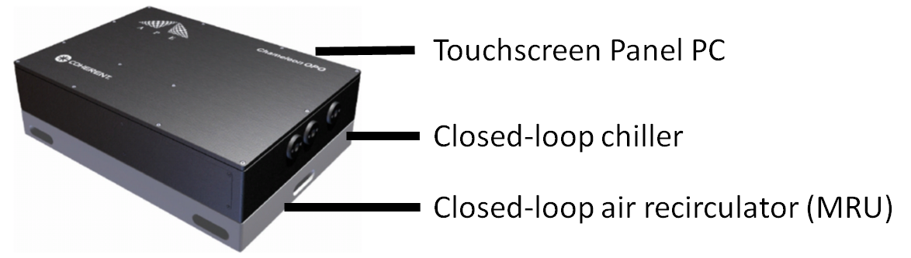

The Compact OPO is supplied with its’ own dedicated controller, chiller, and MRU.

Do not exchange the chiller and MRU with those from the Chameleon.

Do not run the chiller and MRU in a loop with the Chameleon.

OPO and ancillary equipment.

|  |  |  |  |
| --- | --- | --- | --- |
|  | Power Consumption, max, W | Dimensions, LxWxH, mm | Weight, kg |
| OPO head | 100 | 520 x 369 x 158 | 40 |
| Panel PC | 100 | 234 x 128 x 41 | 2 |
| Chiller | 635 | 270 x 200 x 380 | 11 |
| MRU | 180 | 460 x 430 x 85 | 9 |

* Open the OPO crate and check that all components are present. A packing list is supplied in the accessory kit.
* In particular, check for the head itself, the PanelPC and 12Vdc power pack, and the accessory kit. Inside the accessory kit, check for the special Allen key tools, alignment apertures, USB cable, and clamps.
* Note that the OPO head weighs 40kg. Do not attempt to lift the OPO head without help, and use safe lifting practices.
* Carefully place OPO head on the optical table.
* Connect the chiller to the OPO head using the hoses provided.
* Place the chiller away from other heat sources. For example, make sure it is not blowing into the air intake of the Chameleon chiller.
* Fill the chiller reservoir with CoolFlow IGE and switch the chiller on, adding coolant as required.
* Leave the system to thermalize for at least 1 hour (e.g. use this time to complete Chameleon wavelength and power calibrations).
* For a Vision laser, create a pre-compensation curve called ‘OPO’, setting all values to -7000fs2 across the tuning range.
* The MRU can be connected but should NOT be switched on at this time.

# Startup

* Connect the PanelPC to the OPO head using the USB cable provided, and plug in the power pack provided (do NOT switch on at this point).
* Plug in the OPO head to a mains outlet and switch on.
* Wait 20seconds; the PanelPC can now be switched on.
* Note: It is necessary for Service engineering to use a USB mouse (not provided) to access the service functions on the PanelPC.
* The PanelPC should automatically boot into the OPO control program (user mode). Close the application, and right-click on the desktop shortcut. Enter the Service password to the shortcut target as shown in Figure 7.0.1 below. “ -- service “
* Do not allow the customer to see this step!

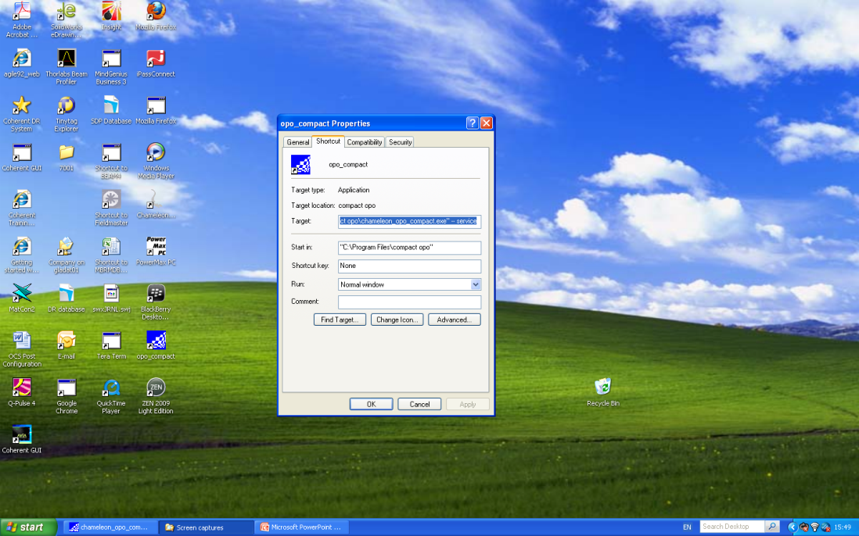

**Figure 7.0.1**

* Re-open the application from the shortcut.
* Go to the Tuning tab and ensure that the ‘Hold’ checkbox is deactivated (Figure 7.0.2 below).

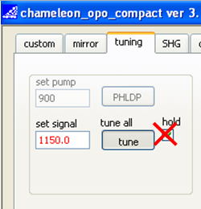

**Figure 7.0.2**

* Go to Windows Explorer and open up the ‘opo compact’ folder (C:\Program Files\opo compact\). Open the settings.txt file. It should be empty. If there is any data in the file then save it under a different name. Now delete all data from the settings.txt file and save.

# Alignment

The following sub-sections describe the alignment of the OPO head to the pump laser and the optical alignment of the OPO itself. There are some special tools required (apertures and shortened 2.0mm and 2.5mm hex wrenches) which should be found in the OPO accessory kit.

!!! Gloves and hairnet should be worn while the cavity is open !!!

Alignment can be divided into some basic steps as follows;

* 8.1 Head Alignment. Position the OPO head on the table and align to the laser, using slit apertures and alignment mode on the Chameleon.
* 8.2 Spectrometer Alignment. Check and adjust the spectrometer and fast PD alignment using the splitter BS2 and steering mirror SM1.
* 8.3 Pump-In Alignment. Again using alignment mode, align the pump-in beam using the two hole apertures positioned before and after the crystal.
* 8.4 Cavity Alignment (first pass). Now with mode-locked operation, align the first pass through the cavity with one hole aperture positioned in the centre of the cavity.
* 8.4 Cavity Alignment (second pass). Align the second pass through the cavity with one hole aperture in front of the cavity end mirror.
* 8.5 Start OPO. Adjust the cavity length to start OPO generation.
* 8.6 Optimisation of power and tuning.

These steps are now described in detail.

## Head Alignment

!!! Use Chameleon Alignment Mode only for this step !!!

* Installation of the Chameleon laser must be complete. Full calibration, using the Rees spectrum analyser, is essential.
* The Chameleon should have been keyed ON and tuning for at least 1 hour before alignment of the OPO is attempted.
* Position the OPO roughly 100mm in front of the Chameleon and carefully remove the top cover (2.5mm hex wrench). Wear gloves and hairnet (spares are provided in the accessory kit) during all work inside the OPO cavity.
* The cavity layout is shown in Figure 8.1.1 with the key components identified. Take a few minutes to familiarise yourself with the layout and beam paths. These will be referred to in the following procedures.

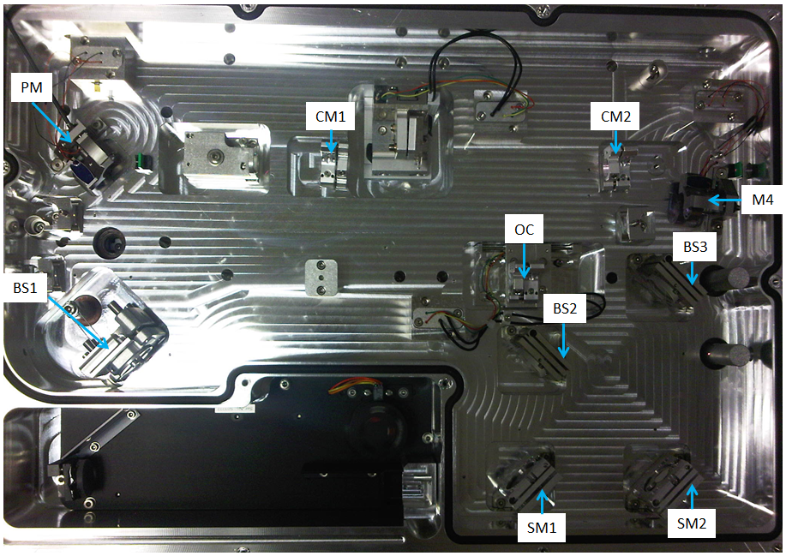

**Figure 8.1.1**

* During the following alignment procedures, it is essential that no optical elements should be adjusted other than those specified. The fixed mirrors, the focussing lens, the crystal, and the spectrometer turning mirror, should never be adjusted.
* Position the slit apertures in the locations shown below.

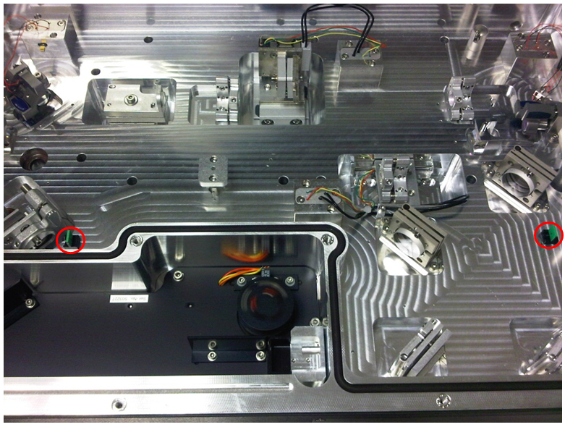

**Figure 8.1.2**

* Select Bypass on the OPO controller.
* Select Alignment Mode on the Chameleon and open the laser shutter.
* Move the OPO head on the table to align the red beam to the slit apertures. Take time to achieve the best possible alignment. A strong peak will probably be seen at 730nm (and harmonic) on the OPO spectrometer.
* When this rough alignment is complete, fix the OPO head to the optical table using the clamps provided and remove the slit apertures.

## Spectrometer and Fast PD Alignment

* Close the Chameleon shutter and take it out of Alignment Mode.
* Remove the Pump-In shutter as shown in Figure 8.2.1 and use it to block the pump-in beam path into the OPO cavity!

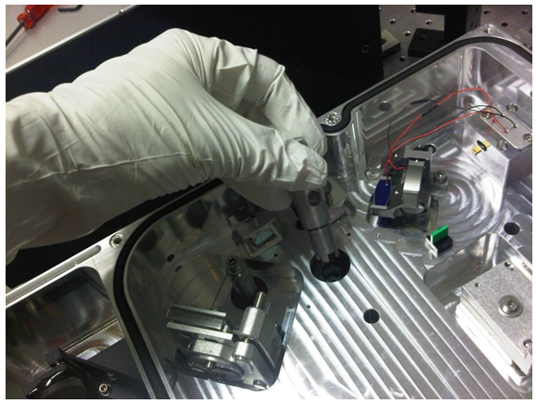

**Figure 8.2.1**

* Only after the beam has been blocked from entering the OPO cavity, tune the Chameleon to 800nm and open the shutter.
* The OPO should still be in Bypass mode. Maximise the spectrometer peak at 800nm using BS2 and SM1. On the Config1 tab, adjust the spectrometer gain (Figure 8.2.2) as required to achieve a signal that is well above the noise floor but not completely saturated.

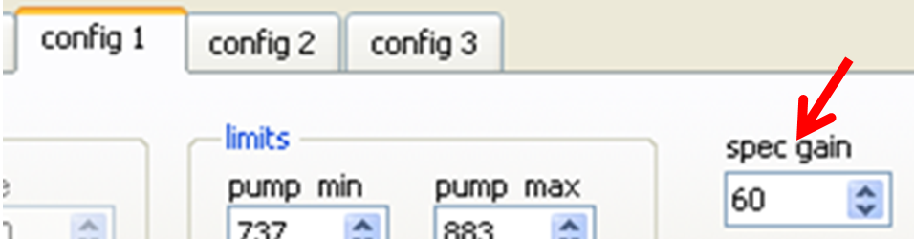

**Figure 8.2.2**

* De-select Bypass mode. Re-adjust BS2, SM1 to maximise the spectrometer signal, and adjust the spec gain to achieve a peak in the 0.2-0.5 range (arbitrary scale).
* Open the Status window from the Custom tab. Verify that the ‘frequenz’ field is showing a value close to 80MHz (Figure 8.2.3). Note this number.
* Tune the Chameleon from 740nm to 880nm in steps of 20nm and verify that the ‘Frequenz’ field remains close to 80MHz.

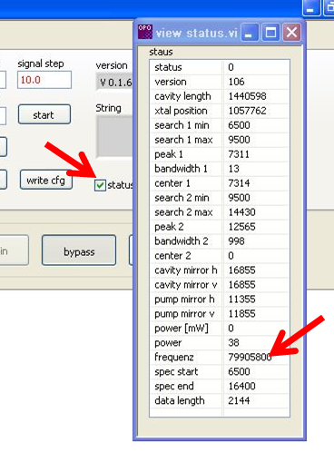

**Figure 8.2.3**

* If the Frequenz value is not available across this wavelength range, then re-adjust BS2 to center the red beam on the window aperture behind SM1. Re-adjust SM1 and the spec gain to maintain the spectrometer peak as described earlier in this section.
* If the Frequenz value is still not available across the 740-880nm range then the fast PD board position maybe adjusted (see Troubleshooting section 10.1, ‘PD board position adjustment’).
* Do not proceed until the pump spectrum and Frequenz values are correct.
* Close the Chameleon shutter.

## Pump-In Alignment

!!! Use Chameleon Alignment Mode only for this step !!!

* On the OPO PanelPC, go to the ‘Mirror’ tab and centre both of the piezo-mounted mirrors (Figure 8.3.1)

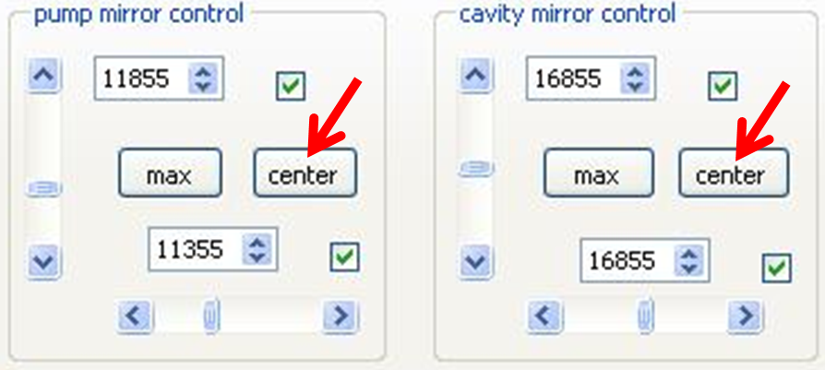

**Figure 8.3.1**

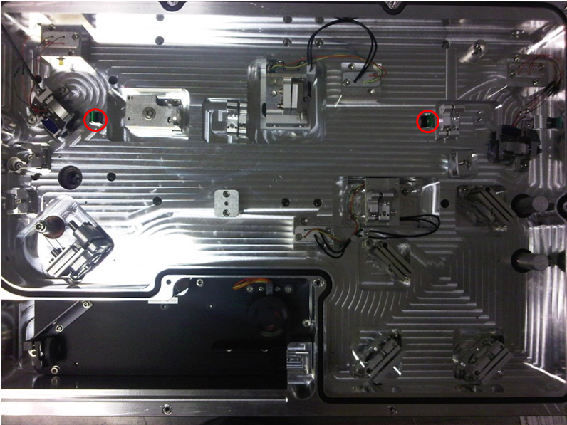

**Figure 8.3.2**

* Position the hole apertures as show in Figure 8.3.2 above
* Select Alignment Mode on the Chameleon and open the shutter.
* De-select Bypass mode on the OPO controller.
* Using only the horizontal and vertical adjustments on BS1 and PM, walk the beam onto the two hole apertures.
* Take time to perfect this alignment before moving on to the next step.
* Take the Chameleon out of Alignment Mode and close the shutter.

## Cavity Alignment

Before beginning this section, compare the Frequenz value for 800nm collected in the previous section against the test protocol supplied in the accessory kit. If it does not fit comfortably between the relevant ‘Without Sliding’ limits, refer to the Troubleshooting section before proceeding (Section 10.2, Adjustment of OC mounting position).

* Place one of the hole apertures at the alignment point in the centre of the cavity (Figure 8.4.1)

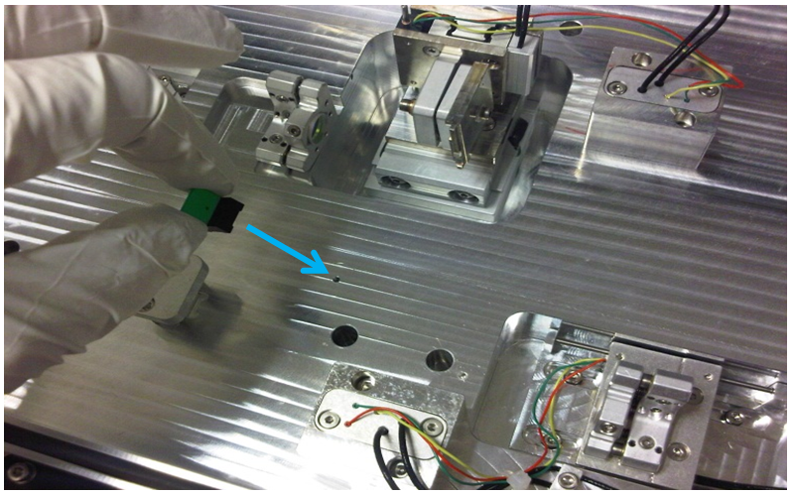

**Figure 8.4.1**

* Tune the Chameleon to 800nm and open the shutter.
* De-select Bypass mode on the OPO controller. Some fluorescence will be seen.
* Using CM2 only, centre the bright spot on the alignment hole (Figure 8.4.2).

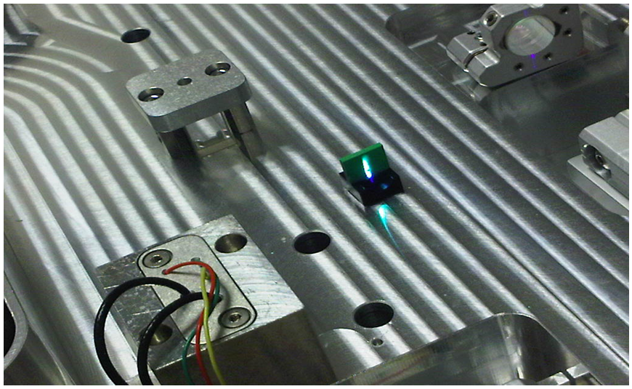

**Figure 8.4.2**

* Now view the alignment aperture from the other side and use the OC to align the bright spot back on to the alignment hole (Figure 8.4.3)

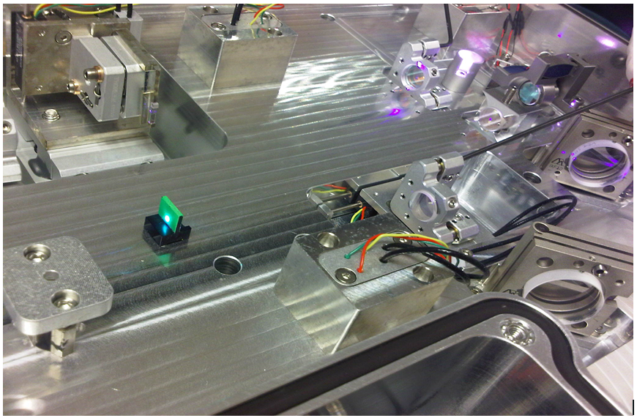

**Figure 8.4.3**

* Now place the alignment aperture in front of M4 (Figure 8.4.4)

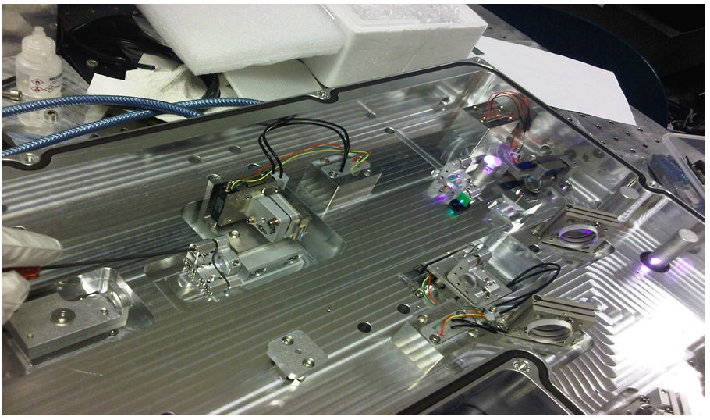

**Figure 8.4.4**

* Centre the spot on the frontside of the aperture using CM1. Adjust the backside reflection using M4. Repeat as necessary.
* It can be useful to remove the aperture in front of M4 and place it in the centre of the cavity again. If the alignment is close then the back-reflex from M4 can be seen and optimised here.
* Repeat these last two steps iteratively until the alignment is optimised. This can take some time.

## Start OPO

* When alignment has been optimised, remove the alignment targets from the cavity.
* Select a wavelength, 1100nm for example, by touching anywhere on the spectrometer window to reveal the dialog box shown (Figure 8.5.1).

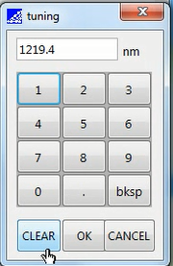

**Figure 8.5.1**

* On the Tuning tab, press SET on the crystal position (Figure 8.5.2)
* Still on the Tuning tab, move the output coupler (Figure 8.5.2) until a bright flash is seen.
* Fine tune the OPO generation using the cavity length adjustments.

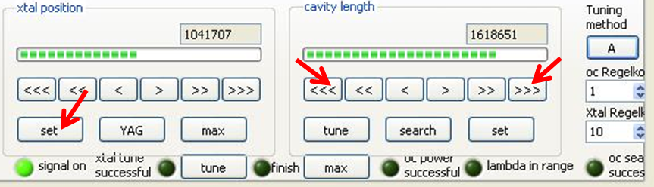

**Figure 8.5.2**

* Note that it is likely that sections 8.4 and 8.5 will have to be performed more than once before OPO generation is achieved.

## Optimisation

Once the OPO cavity has been started, the signal power should be optimised and calibrated.

* For a Vision laser, make sure the ‘OPO’ pre-compensation curve is being used (see section 6.0).
* Tune the OPO to 1100nm (800nm pump) manually, then press the Tune button (Figure 7.0.2). Do not check the Hold box.
* Adjust BS3 and SM2 to maximise the signal peak on the spectrometer and re-adjust the spec gain if necessary (Figure 8.2.2).
* Position a suitable external power meter to read the OPO signal and open the Signal Out shutter.
* Adjust M4 and OC iteratively to optimise the signal power, while checking for the best overlap of the mixing products behind CM2 with the residual pump beam.
* Optimise the crystal position using the software controls < >.
* For a Vision laser, optimise the setting of the ‘OPO’ re-comp curve and save it.
* Go to the Config3 tab and adjust the gain value to match OPO PD to the external meter (Figure 8.6.1). Do NOT adjust any of the other values.

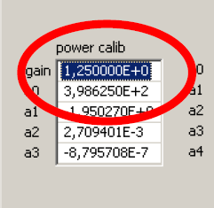

**Figure 8.6.1**

* Go to the Config2 tab and press ‘Calc’ on both crystal and OC position (Figure 8.6.2)

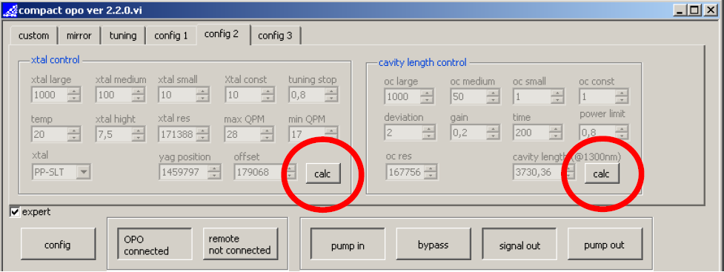

**Figure 8.6.2**

* Tune the OPO to 1020nm.
* Close the Signal Out shutter and walk BS3/SM2 again to optimise the signal peak on the spectrometer. Aim for a value of 0.8-1.0 but not saturated, adjusting the spec gain as appropriate.
* Close the Chameleon shutter and replace the Pump In shutter (in the closed position).
* Remove all tools from the cavity and close the cover of the OPO. Progressively and evenly tighten the bolts holding the cover down against the O-ring seal.
* Turn on the MRU and wait 5 minutes. Tune the OPO to 1300nm (check the Hold box). When tuning is complete (Status: OK), press Calc again.
* Check the ‘Hold’ box on the Tuning tab.
* Select the Mirror tab – both active mirrors should still be centered (per Figure 8.3.1).
* Now go to the Config screen as shown in Figure 8.6.3 below

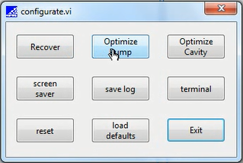

**Figure 8.6.3**

* Press Optimise Pump and wait for the ‘Adjusting’ status to return to ‘OK’.
* Press Optimise Cavity and again wait for the status to return to ‘OK’.
* Check the position of both active mirrors. Some deviation is acceptable but if either of them is near to their hard limits then the cavity alignment should be adjusted in order to center them. Switch off the MRU and tune to 1100nm (800nm pump), center both mirrors, re-optimise the signal power and overlap, and re-try the Optimise Pump and Optimise Cavity routines.
* Repeat the ‘Calc’ routine at 1100nm and 1300nm (this should always be the last thing done after any adjustment of cavity alignment).
* On the ‘Custom’ tab, press ‘write config’.
* Close the OPO cavity and switch the MRU back on.

# Complete Installation

## Data Collection

Now tune the OPO iteratively to achieve the specified range of values. This achieves two things;

* Teaches the OPO optimum crystal and OC positions for fast tuning.
* Demonstrates the specifications and builds up a set of tuning curves as a record for the installation.

Using a suitable power meter, record the signal power in a spreadsheet

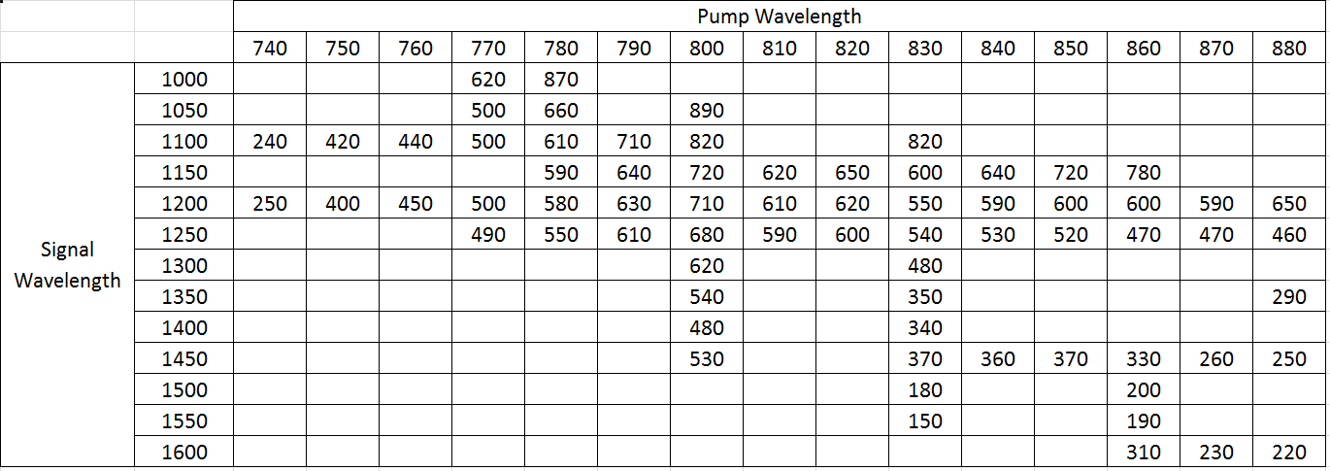

Depending on the time available, more or less points can be collected but, as an absolute minimum, the key specifications should be recorded (e.g. 740 – 800 – 880 pump; 1000 – 1100 – 1600 signal; 700mW@1100; for an UltraII pump). More points are highly desirable since it will help the OPO to learn.

## Save OPO folder

Using a USB memory stick, copy the entire OPO folder from the PanelPC (C:\Program Files\Compact OPO) and save it as part of your installation record. These files will be useful for recovering the OPO in the event that the PanelPC fails in the future.

## Customer Training

Remove the service password from the desktop shortcut and open the application in customer mode.

If time allows, test the TeamViewer remote desktop application (see section 11).

Guide the customer through the operation of the system, using the User Manual as appropriate.

* Demonstrate how to toggle between Chameleon-only and Chameleon+OPO operation using the ‘Bypass’ function.
* Demonstrate tuning of the OPO for a fixed pump wavelength.
* Demonstrate tuning of the OPO at a fixed signal wavelength while tuning the Chameleon.
* Demonstrate opening/closing of shutters to access the pump and signal beams.
* Referring to the product datasheet, explain the tuning ranges since these depend on the type of pump laser used. Also show that certain pump/signal wavelength combinations are not available (short pump/long signal, and vice versa).
* The customer should understand that the Chameleon pump laser should be warmed up each day for at least 20minutes before using it to pump the OPO. The chiller and MRU are typically left running 24/7.
* The customer should understand that any day-to-day variation in OPO performance is most likely related to the pump laser and any troubleshooting should always start with the Chameleon.
* If time allows, ask the customer to establish an internet connection to the PanelPC and test the Teamviewer/Bomgar link (see section 11).
* Discuss the functions available under the Config screen (Figure 9.3.1).

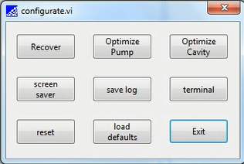

**Figure 9.3.1**

Screen Saver – makes the screen dark for low-light experiments. Touching the screen brings it back on again.

Terminal – opens a terminal window allowing the user to send serial commands to the OPO.

Load Defaults – re-loads factory settings. This should not be used by the customer before consulting Coherent support.

Reset – re-starts the tuning process for the current wavelength. It can be used if a tuning attempt fails, although the same effect can be achieved by tuning away to a new wavelength and then back again.

Recover – starts a recovery routine where a YAG crystal is used to generate 1064nm light in the cavity in order to re-optimise the active mirrors. This should not normally be necessary therefore it should NOT be used without first consulting Coherent support.

Optimise Pump/Cavity – these functions initiate optimisation routines for the two active mirrors. The customer should be cautioned against using these functions unless strictly necessary. If the OPO power is low (>100mW less than normal for a certain wavelength combination), the Chameleon pump laser should be checked for output power and good thermalisation before using these Optimise functions. Using them routinely can result in the mirrors ‘walking’ off from the best alignment.

Finally, the hands-free nature of the Compact OPO should again be emphasised. There are no user-serviceable components, and warranty is void if opened or operated in service mode by the customer.

# Troubleshooting

## PD board position adjustment (ref: section 8.2)

If the fast PD board position needs to be adjusted to make all the frequency values available as displayed in the Status window, carefully remove the panel from the outside of the OPO head located behind SM1. The left-hand board is the frequency board. Loosen the two fixing screws and move until the ~80MHz frequency is shown at all wavelengths across the pump tuning range. Fix the board in place and replace the cover.

## Adjustment of OC mounting position (ref: section 8.4)

Refer to the ‘frequenz’ value recorded for 800nm in section 8.2. In some cases the Chameleon repetition rate may be at either end of the range of variation expected in the manufacturing process. Consult the test sheet supplied in the OPO accessory kit. An example is shown in Figure 10.2.1 below.

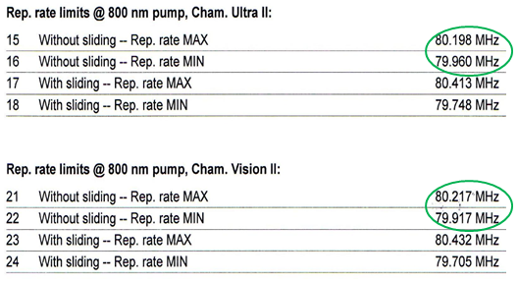

**Figure 10.2.1**

Note the different ranges for Ultra and Vision. If the repetition rate at 800nm is within the ‘Without Sliding’ limits (green), then no action is required and alignment can proceed. However, if the repetition rate is outside (or close to the edge) of these limits, then the OC mechanical assembly will need to be moved before alignment can proceed.

* Loosen the three bolts fixing the OC assembly (Figure 10.2.2, red arrows)
* Move the assembly as indicated and re-fix the assembly.

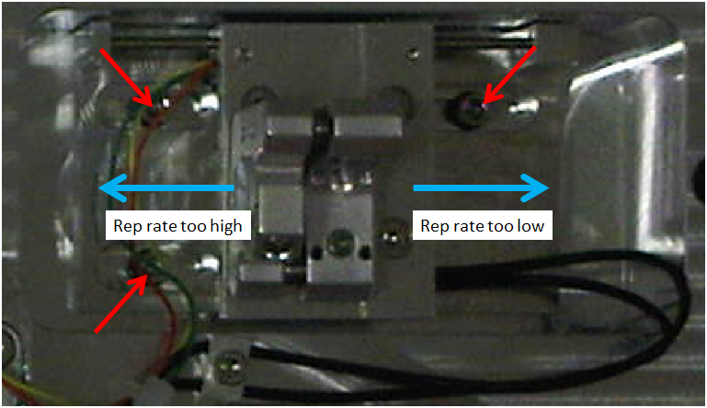

**Figure 10.2.2**

If the rep rate is outside the ‘With Sliding’ limits then call Factory Support (see section 13.0).

## ‘No Pump’ message

If a spectrometer peak is displayed for the pump wavelength but a ‘No Pump’ message is seen, close down the OPO PanelPC (Start->Shutdown). Power off the OPO head. Power on the OPO head and wait 20seconds. Re-start the PanelPC.

This message will also appear at initial start-up when the system is not aligned.

## Poor signal power

The cause for poor OPO performance is almost certainly related to the pump laser.

* Pump laser not warmed up correctly.
* Poor alignment of pump laser into the OPO.
* Go back and check the power calibration of the Chameleon using an external meter.
* The CW breakthrough should also be checked using a Rees spectrum analyser. It is not possible to sufficiently detect partial breakthrough with other devices.
* Incorrect Chameleon prechirp setting (Vision pump only) – see section 6.0
* Poor OPO cavity alignment. Center the active mirrors, and check the alignment thoroughly from section 8.1 onwards.

## Compact OPO software does not connect to the head

Go to the ‘OPO Not Connected’ button and command the OPO to connect. If this does not display a ‘USB……’ address then shut down the program and re-start the PanelPC before re-trying.

If the OPO does not connect automatically in customer mode, check the interface.cfg file (C:\Program Files\Compact OPO\interface.cfg) and ensure that the auto-connect value is set to 1.

## Configuration settings corrupted during installation.

Press “Load Defaults” in the config menu and choose defaults.cfg (C:\program files\OPO compact\) to load the factory settings.

## In case of laser replacement

If the Chameleon pump laser needs to be changed for any reason, remember that the existing settings file ((C:\program files\OPO compact\) should be saved under a new name (e.g. ‘settings_old_ddmmyy’) and a new empty settings file created. The new laser will have a different set of repetition rate values and the full setup in section 8.0 will need to be done again, paying particular attention to the ‘Frequenz’ value as per section 8.4 and adjustment of the OC, if necessary, as per section 10.2.

## De-install of Compact OPO

If the Compact OPO is to be de-installed, shutdown the PanelPC and switch off the OPO head. Remember to drain the baseplate using the open-ended hoses provided in the accessory kit! Re-pack the OPO, cables, hoses, etc., in the original packaging.

# Chameleon MPX

The following section refers specifically to the Chameleon MPX. It assumes full familiarity with the Chameleon Compact OPO

## Introduction to the Chameleon MPX.

The Chameleon MPX is clearly a variant on the Compact OPO but is marketed separately and has a separate datasheet. Useful information can be found on the datasheet at coherent.com, and in PIB 14-38.

It is designed very specifically for multiphoton imaging, hence the name (**M**ulti**P**hoton e**X**tension). The key specification changes are:

* Increased top-end pump range
* Negatively-chirped pulses designed to compress to 130-150fs on-sample after typical microscope dispersion.

FAQ’s

* What is different from the standard Compact OPO?
* Optical Specifications (see datasheets)
* No MRU
* Cavity design changes
* What is the same?
* Size, shape, beam positions, and software command set
* No changes from the customer side
* Can an existing Compact OPO be upgraded?
* No
* Do we offer Idler / MaxIR / VIS options for the MPX?
* No

Please note that the PanelPC supplied with the MPX runs a Windows7 OS and a different software package to the Compact OPO. It is planned that all Compact/MPX systems will migrate to the Windows7 platform within the next months.

## MPX cavity overview

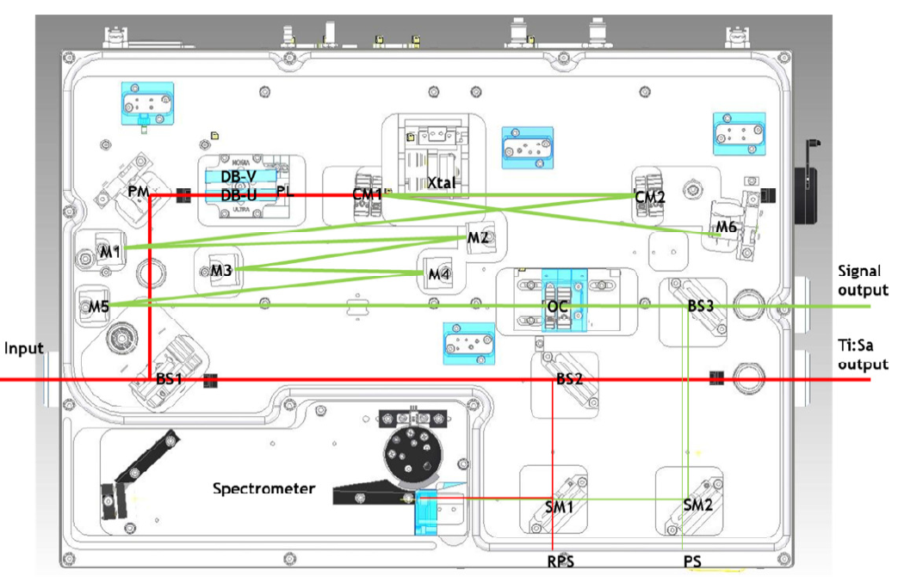

## MPX cavity alignment

* Refer to sections 4, 5, 6, and 7 of this document for pre-installation, un-packing, and initial setup. There is no MRU.
* Follow the alignment steps in 8.1, 8.2, and 8.3 as you would for a standard Compact OPO. These are broadly the same, however, please note the following changes.
* To enter Service mode, there is no need to change the shortcut target. Open the program in customer mode, then open a terminal window from the Config menu. Enter the command as shown below to enter Service mode.

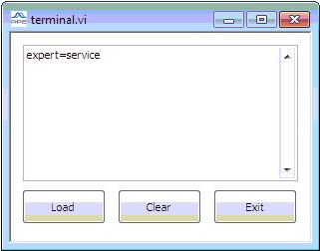

* Ensure that the dispersion block between the pump mirror (PM) and the first curved mirror (CM1) is correctly positioned according to the type of pump laser (Ultra or Vision) as shown below. If the block needs to be rotated, then loosen the four bolts indicated and re-attach in the correct orientation. Take care not to loosen or re-align the focusing lens.
* Please ensure that the dispersion block is aligned firmly against the back wall of the pocket in the direction shown by the red arrows.

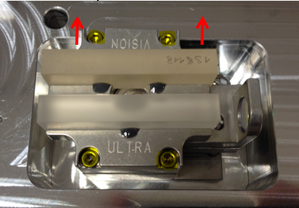

* The central alignment point is in a different position for the MPX.

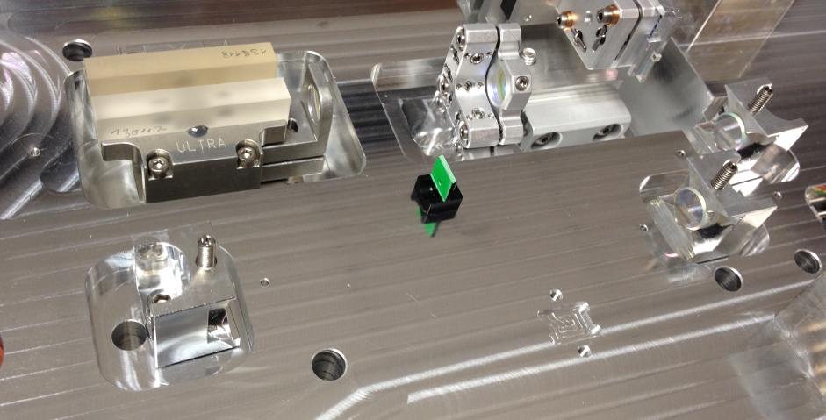

* Alignment of CM2 is now with the alignment target placed in front of the OC.

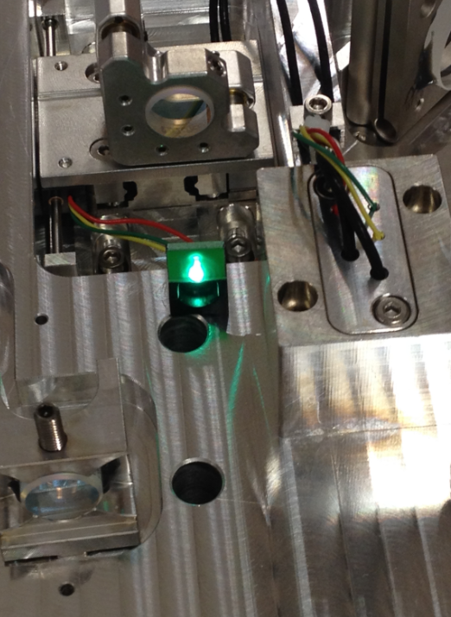

* Move the alignment target to the centre position, and align the return path from the OC.

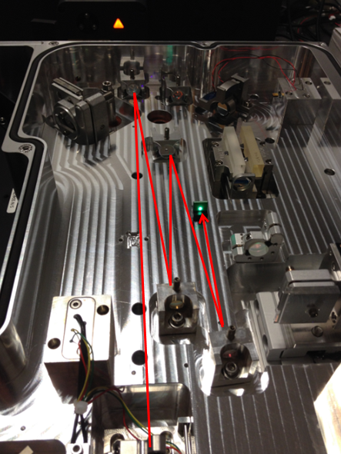

* Place the alignment target in front of the OC again to help align the second pass from M6.
* Search for the ‘flash’ position and optimise power as before.
* Find lasing at 800-1100nm and press ‘calc’.
* Go to 800-1200nm and optimise the mixing products behind CM2.
* Go to 880-1200nm and press ‘calc’3.
* Go to 880-1300nm and press ‘calc’.
* Complete the installation as outlined in section 9. Note that the file path for the OPO data is slightly different on the MPX (C:\ProgramData\APE\compact opo)

# Remote Diagnostics

In many cases, useful service and diagnostics can be carried out on the Compact OPO remotely.

In order to take advantage of this feature, the customer must provide an internet connection. Normally this is connected via the wireless adaptor on the PanelPC, or via one of the Ethernet ports.

In some cases, the customers’ IT department have to enable this so it is more efficient to plan ahead for the remote session. Ideally, you should test the remote connection during installation of the Compact OPO.

Note 1: You will need an assistant at the customer site to help set up the session and operate the Chameleon (open/close shutter, etc.)

Note 2: If you need to open the output shutters of the OPO, please pre-confirm with your assistant that it is safe to do so.

Note 3: Please use caution when entering the service passwords. Please ask the customer not to observe this input. If the customer uses this password to access service mode then all warranty will be voided.

There are two methods for connecting to the PanelPC, either by Teamviewer or Bomgar.

## Teamviewer method.

The Compact OPO PanelPC controller is shipped with the Teamviewer desktop sharing application pre-loaded.

* Ensure that Teamviewer is loaded on your own laptop. We have licences in GDP but you can use the free version.

<http://www.teamviewer.com/en/download/windows.aspx?utm_expid=60202728-12&utm_referrer=http%3A%2F%2Fwww.teamviewer.com%2Fen%2Fhelp%2F9-Does-it-work-behind-firewalls-proxy-server-and-NAT-routers.aspx>

* Establish an internet connection to the PanelPC
* Your assistant should open the Teamviewer application on the PanelPC. They should see a screen like this;

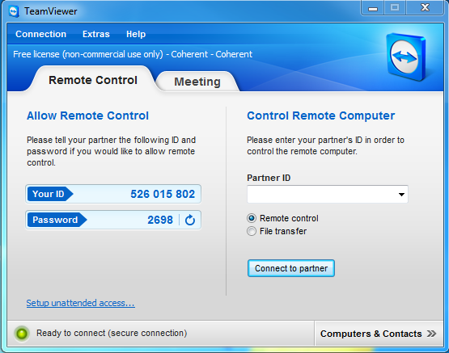

**Figure 12.0.1**

* They should send you the ID and Password that they see on the left of the PanelPC screen.
* Open Teamviewer on your laptop. Type the ID that your assistant has sent you into the ‘Partner ID’ field on the right-hand side of the screen and ‘Connect To Partner’.
* When prompted, enter the password that you have been given.
* In a few seconds you should be able to see the desktop of the PanelPC. You can now control the Compact OPO. Your assistant will have to key the Chameleon ON and open the shutter.

## Bomgar method

Bomgar remote connection should be familiar to all Chameleon-trained Field Service Engineers. From the Bomgar ‘Start’ button, either send an email to your assistant and ask them to follow the prompts, or ask them to navigate to

<https://connect.coherent.com/>

and enter the Session Key that you have provided.

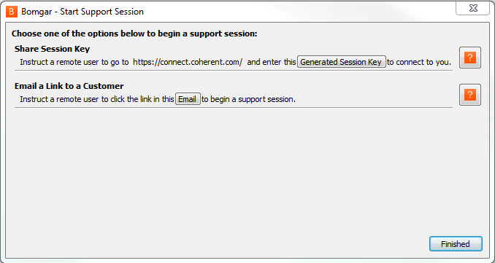

# Spares List

Refer to Document D144007 for latest revisions.

|  |  |
| --- | --- |
| Coherent PN | Description |
| 1213872 | SPARE, CHAMELEON, COMPACT OPO, SPECTROMETER, |
| 1213873 | SPARE, CHAMELEON, COMPACT OPO, FREQUENCY SENSOR BOARD, |
| 1213874 | SPARE, CHAMELEON, COMPACT OPO, POWER SENSOR BOARD, |
| 1213875 * | SPARE, CHAMELEON, COMPACT OPO, INTERNAL CONTROL BOARD, |
| 1213876 | SPARE, CHAMELEON, COMPACT OPO, ALIGNMENT TOOLS, |
| 1213877 * | SPARE, CHAMELEON, COMPACT OPO, PANEL PC, |
| 1218517 | SPARE, CHAMELEON COMPACT OPO, SHIPPING CRATE, |

* NB: If ordering a replacement internal control board or PanelPC,

it is essential that the serial number of the OPO is noted on the order.

# Further Support

Requests for further information and escalations should be directed to Coherent Scotland, not to APE.

Primary Contacts

Owen Morrison Service Support [owen.morrison@coherent.com](mailto:owen.morrison@coherent.com)

Richard Skilling Applications [richard.skilling@coherent.com](mailto:richard.skilling@coherent.com)

Secondary Contact

Iain Macphee Service Support [iain.macphee@coherent.com](mailto:iain.macphee@coherent.com)